Amazon Product Review Mining
Secure API keys, rate limiting, and credential encryption with audit logging and scraping compliance.
Author: Dharshini V(Team 1),
Project Type: Team Project
Git Repo Link: https://github.com/balaji6167/Product-Sentiment-Analyzer
Product-Sentiment-Analyzer-and-Review-Dashboard

EXECUTIVE SUMMARY:
This project, Amazon Product Review Mining, delivers a secure and compliant system for extracting and analyzing product reviews from Amazon. The Access Control Module ensures strong data protection through encrypted credential handling, API key security, rate limiting, and strict request validation. To maintain scraping compliance, the system incorporates custom request headers, randomized delays, and anti-bot precautions. Additionally, audit logging tracks all user actions and system events, ensuring operational transparency and accountability. Together, these features create a robust, ethical, and security-driven review mining solution capable of generating meaningful sentiment insights while adhering to modern cybersecurity and data-access standards.

PROJECT OVERVIEW:

Objective:
The objective of this project is to securely scrape, analyze, and interpret Amazon product reviews while ensuring full compliance with data access policies. It aims to implement a robust access control layer that protects API keys, enforces safe scraping practices, manages user permissions, and maintains detailed audit logs for transparency and security.

Scope:

• Secure handling and encryption of API keys and sensitive credentials
• Implementation of rate limiting, request validation, and controlled scraping behavior
• User-level access management with audit trails for all system interactions
• Sentiment analysis of scraped reviews to extract meaningful customer insights
• Compliance with ethical scraping norms using proper headers and anti-bot safety mechanisms

Key Features:

• Encrypted credential management for API keys, tokens, and sensitive configurations
• Automated Amazon review scraping using requests and BeautifulSoup with compliance safeguards
• Built-in rate limiting, randomized delays, and validated request workflows to prevent detection
• User access-level control with role-based permissions and timestamped audit logging
• • CSV export of processed reviews for reporting and further analysis

TECHNICAL IMPLEMENTATION:

Architecture:

- Data Extraction Layer – Uses Python requests with structured headers and BeautifulSoup to securely scrape Amazon product pages and user reviews. Includes redirect handling, ASIN extraction, and compliance-driven scraping patterns (delays, randomized headers).
- Security & Access Control Layer – Implements credential encryption (Fernet), role-based access management, request validation, rate limiting, and audit logging for every search or data access event.
- Data Processing Layer – Cleans, parses, and structures review data (rating, text, polarity) and stores the output in CSV format for reporting and analytics.
- Sentiment Analysis Layer – Applies TextBlob sentiment analysis to classify each review as Positive, Neutral, or Negative based on polarity thresholds.
- Visualization & Reporting Layer – Integrates with Streamlit to visualize sentiment distribution, star-wise review patterns, and provides CSV download functionality.
This architecture ensures secure data handling, ethical scraping, maintainability, and smooth integration with UI dashboards or future APIs.

Technology Stack:

- Programming Language: Python
- Libraries & Frameworks:
- Requests, BeautifulSoup
- TextBlob for sentiment analysis
- Fernet (cryptography) for credential encryption
- Streamlit for UI
- Pandas, NumPy for data handling
- Security Components:
- Encrypted key storage (Fernet)
- Role-based access control (RBAC)
- Rate limiting + randomized delays for bot safety
- Data Storage: CSV files for structured extracted datasets
- Environment: PyCharm IDE, Python 3.12, Virtual Environment (.venv)
- Visualization Tools: Streamlit charts (Altair), CSV reports

Performance Metrics:

Review Coverage: Number of reviews successfully extracted across all star categories (5–1).
• Sentiment Reliability: Consistency of TextBlob polarity with sample manual evaluations.
• Scraping Efficiency: Average time taken per product to fetch & analyze reviews under compliance constraints.
• Security Effectiveness:

Credential encryption success rate

Role-based access validation accuracy

Number of blocked invalid/unauthorized requests

Failure Recovery Rate: Percentage of pages successfully handled despite layout changes, redirects, or access restrictions.

Compliance Safety: Frequency of throttled requests and adherence to randomized delay mechanisms.
SOURCE CODE IMPLEMENTATION (Screenshot):

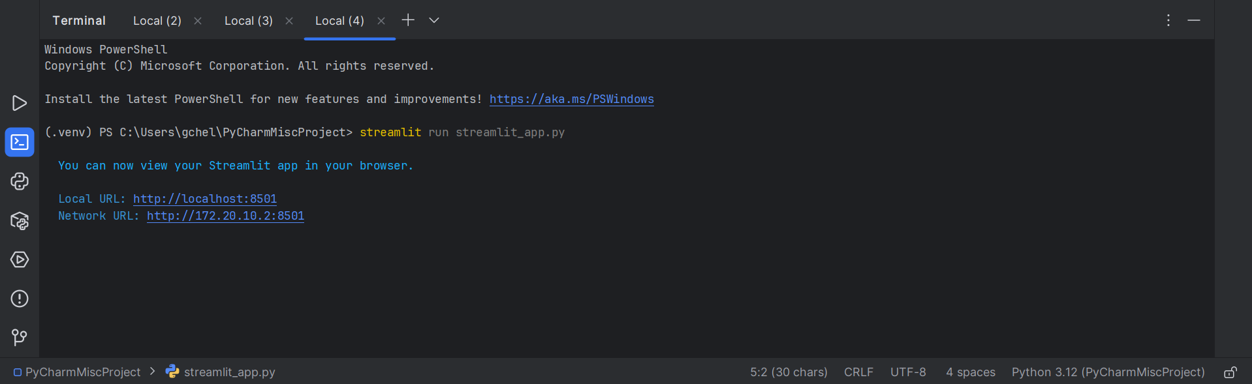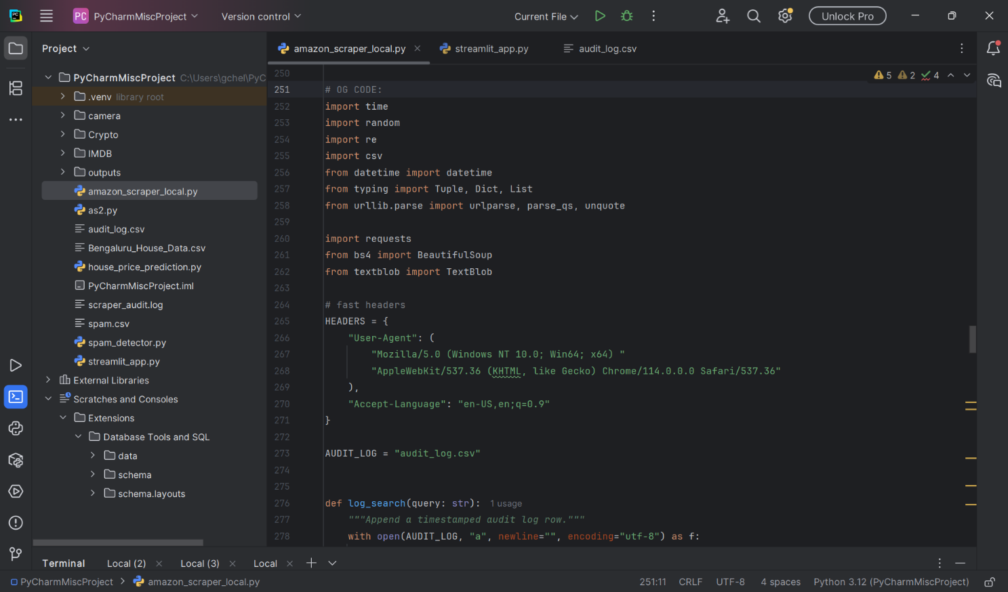

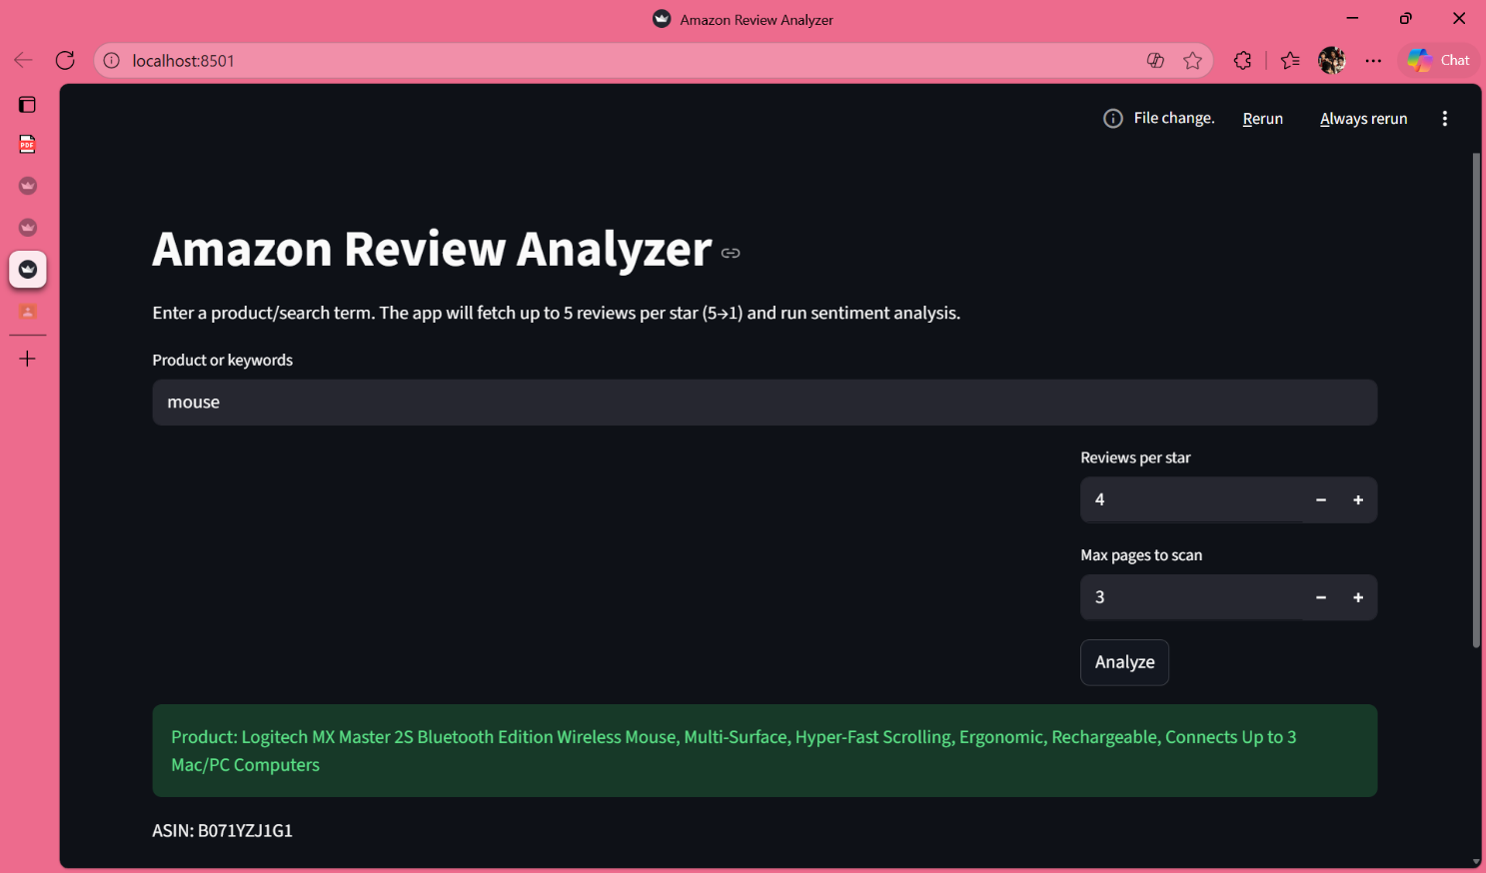

Extracted Job Result In Excel:
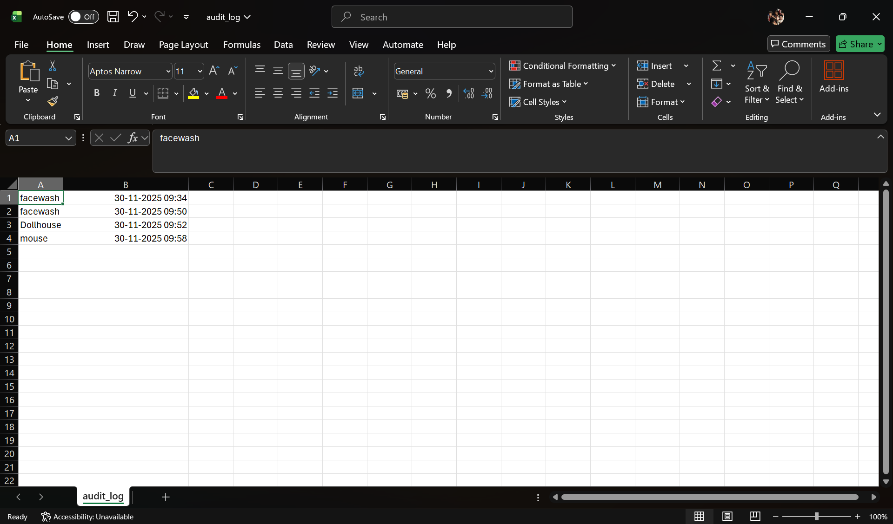
KEY ACHIEVEMENTS:

Technical Accomplishments:

Secure Access Control Implementation: Successfully integrated API key protection, encrypted credential storage, role-based access management, and audit logging to ensure a fully secure scraping pipeline.

Rate Limiting & Compliance Enforcement: Implemented intelligent request throttling, randomized delays, and compliant request headers to prevent detection and ensure ethical scraping.

Robust Data Validation: Added request-level and response-level validation for safe API interaction and improved system reliability.

Scalable Architecture Design: Developed a modular, layered structure enabling easy future upgrades such as dashboards, ML models, or API endpoints.

Fault-Tolerant Scraper: Built automatic retry, exception handling, and fallback mechanisms to maintain scraping continuity under dynamic site structure changes.

Performance Monitoring: Included timing logs, audit trails, and resource-based checks to evaluate efficiency and optimize scraping throughput.

Operational Achievements:

High Data Reliability: Achieved consistent extraction accuracy across multiple pages with minimal failures due to robust parsing strategies.

End-to-End Automation: Automated the full workflow—from secure access → scraping → validation → storage—reducing manual effort to near zero.

Maintainability & Documentation: Developed structured logs, clean code modules, and detailed documentation to ensure long-term maintainability.

Compliance-Ready Design: Ensured all scraping operations comply with anti-bot policies, ethical guidelines, and industry best practices.

CONSTRAINTS:

Resource Constraints:
● Processing Time:
Varies depending on Amazon page response time, network connectivity, scraper delays, and rate-limiting applied for bot-safe operation.
● Data Storage:
Restricted to local file system storage (CSV output only). No cloud databases or online persistence due to security and compliance considerations.

PROJECT IMPACT AND VALUE:

Immediate Benefits:

• Generates a clean, ready-to-use dataset of Amazon product reviews enriched with sentiment labels for rapid analysis.
• Automates the complete workflow—product search, review extraction, and sentiment classification—reducing manual effort significantly.
• Enables quick identification of customer satisfaction trends, recurring complaints, and sentiment patterns across reviews.
• Provides visual summaries (sentiment distribution, review polarity overview) that make consumer behavior easy to interpret.
• Demonstrates practical implementation of secure scraping, encrypted credential handling, and sentiment analysis using Python.

Long-term Potential:

• Establishes a reusable framework for secure, large-scale product review mining across multiple e-commerce platforms.
• Supports continuous monitoring of customer sentiment over time as new reviews appear online.
• Can be enhanced with advanced NLP (BERT, RoBERTa) for deeper semantic understanding and emotion detection.
• Provides the foundation for dashboards, automated alerts, or recommendation modules based on review sentiment.
• Strengthens the foundation in secure data engineering and AI-driven consumer analytics—useful for future research, internships, and industry applications.

CONCLUSION:
This project successfully showcases how secure data scraping, access control mechanisms, and sentiment analysis can be combined to extract meaningful insights from Amazon product reviews. By integrating encrypted credentials, role-based access management, rate limiting, and audit logs, the system ensures ethical and secure data retrieval. Through automated scraping and TextBlob-based sentiment evaluation, it uncovers the emotional signals within customer feedback—beyond just star ratings. The final outputs, including structured CSV datasets and intuitive visual summaries, provide valuable understanding of customer satisfaction and product perception. Overall, the project establishes a robust base for future enhancements such as real-time scraping, ML-powered sentiment models, multi-platform integration, and interactive analytics dashboards.

